**Reference: DHCS** [**BHIN 23-025**](https://www.dhcs.ca.gov/Documents/BHIN-23-025-Medi-Cal-Mobile-Crisis-Services-Benefit-Implementation.pdf)

**Documentation Requirements for Mobile Crisis Encounter**

**Mobile Crisis Response Encounter via the General Progress Note**.

A Progress Note must be completed for each Mobile Crisis Encounter provided to a client. The Mobile Crisis Team shall create a progress note(s) that describes all service components delivered to the beneficiary, including referrals to ongoing supports made as part of the mobile crisis services encounter. A complete encounter must include documentation of the four minimum components specified in BHIN 23-025. If documenting any of the required minimum elements separately (i.e.: mobile crisis 72hr follow up), they would be entered via *never billable note(s)*. A complete encounter must include documentation of the four minimum components to be considered a qualifying mobile crisis service for Medi-Cal reimbursement.

* If the mobile crisis team transports a client to an appropriate level of care or treatment setting as part of the mobile crisis service, they may bill for mileage as an **add-on code** to the mobile crisis encounter bundled rate.
* If the mobile crisis team transports or accompanies a client who is being transported by an NMT, EMS provider or LE, each team member may bill for the transportation time separately in a billable progress note in addition to the mobile crisis bundled rate and mileage.

**Entering the Mobile Crisis Service Encounter in CCBH:**

Select New Progress Note > Individual Progress Note

* Start Date = Date of actual mobile crisis encounter
* Graphical user interface, application

  Description automatically generated
* Enter Encounter: Select service as **Mobile Crisis Svcs**
* Enter service duration as total service time of encounter (bundled rate is flat rate regardless of service time entered, however service time should be entered for data/tracking purposes)
* Enter documentation (not billable, entered for tracking purposes) *enter in minutes i.e.: 0:45

**Continuing entering Encounter Assignment/billing parameters**

* **Provided At** must be **Mobile Crisis** – this indicator is what triggers the appropriate billing within the billing set up “on the back end” for the bundled rate for the mobile crisis response benefit.
* **Intensity Type** must be **Emergency.**

* Select **Diagnosis** and choose diagnosis – diagnosis selected must be an ICD-10 mental health diagnosis or appropriate MH Z-code.

**Adding Mileage Service Code to Encounter**

If the Mobile Crisis Team provides direct transportation of the client to another level of care or treatment setting, mileage may be claimed as an add-on code as part of the Mobile Crisis Service Encounter. This will be added to the same progress note encounter as an additional add-on code using the “Add Encounter” option on the Encounter Ribbon.

Return to Encounter Tab – Encounter ribbon will now be Blue and show Mobile Crisis Svcs as service encounter selected.

MOBILE CRISIS MILEAGE – ENCOUNTER – MILEAGE (DISTANCE)

* Click on Add Encounter to enter the add-on service code(s) for Mobile Crisis Mileage

Enter the staff ID, enter service code Mobile Crisis Mileage (SC 660), and enter Mileage in the Service Duration box.

* Mileage may be claimed for distance from the location of the initial crisis encounter/response location to the facility where client is being transported.
* Milage should be entered in the Service Duration box in Minute format. **1 minute = 1 mile.** Mileage must be entered in whole numbers only.
* Do not enter any data in the travel or documentation boxes.
* You will need to re-enter the client assignment, billing parameters and diagnosis again – these must match what was entered when completing the encounter for the Mobile Crisis Svcs.
* Click Save.

Follow the standard process of completing the Assignment and Billing Parameters, Diagnoses, and Click Save.

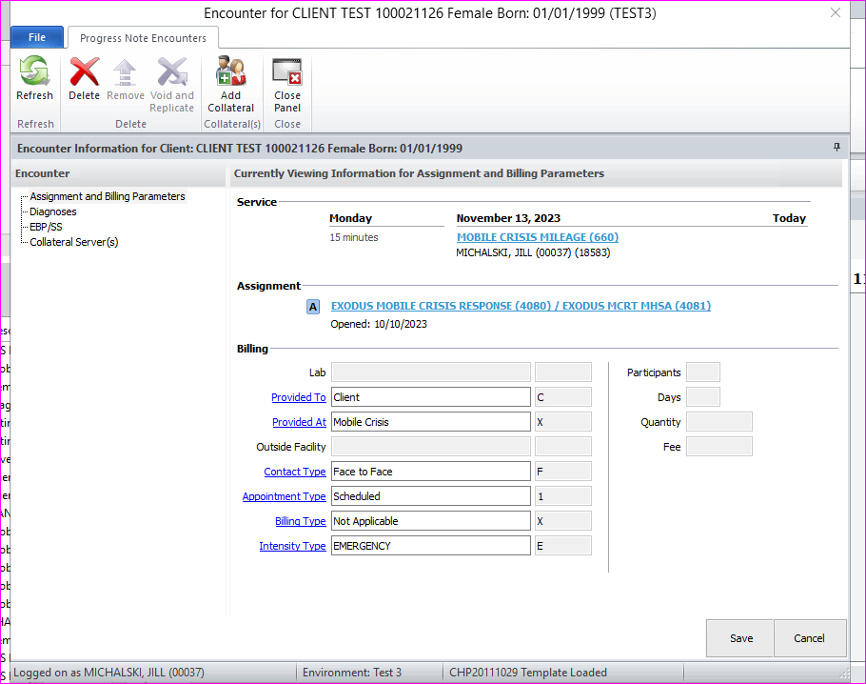

The Mileage is now attached as an add-on service to the Mobile Crisis Encounter progress note for billing.

Once you save encounter entry – both service codes for the encounter will appear in the Encounter box.

**Enter Client Narrative**

* Select General Progress Note template or use Free Flow/Form Narrative. It is recommended to use of General Progress Note with provided prompts.
  + Include brief narrative to support travel time and mileage if added to encounter: “*MCRT provided direct transportation from client home in El Cajon to Alvarado Hospital – travel time 20min, mileage 15 miles.”*
  + Progress Note narrative must include the following components per BHIN 23-025 in order to qualify as a mobile crisis response encounter reimbursable by Medi-Cal
    - completion of F2F Crisis Assessment (indicate “see Crisis Assessment for DOS X/XX/XX)
    - crisis planning or rationale if not completed,
    - warm hand off (as applicable),
    - referrals (as applicable)
    - and documentation of planned follow up check in to be completed within 72 hrs.
      * The follow up check in may be documented on a separate never billable information note due to requirement to enter and final approve PN within 24 hrs.
      * When entering the follow up check in(s) required and provided within 72 hours, these would be entered via a **Never Billable Progress Note** and the date of service selected should be actual date the follow up is provided, however in the narrative, provider should indicate that follow up is part of mobile crisis response/encounter provided xx/xx/xx.
  + The progress note narrative should also document:
    - Name/title/credential of all mobile crisis team members who participated in the mobile crisis response,
    - Documentation that existing problem list was reviewed/updated as appropriate. If the client does not have an existing Problem List, the mobile crisis team must add a new Problem List and document this.
  + Save and final approve progress note within 24 hours/1 calendar day of encounter.

**Claiming Transportation time for direct transport of client (or when accompanying client):**

The transportation time can also be claimed when the Mobile Crisis Team provides direct transportation of the client to another level of care or treatment setting as a result of the crisis response/encounter.

Travel/transportation time – including time spent waiting with the client - may be claimed *separately* by each member of the mobile crisis team that participated in transport of the client.

Alternately, if the team or a team member accompanies the client to another level of care inside a transport vehicle (NMT, EMS, LE) but is not providing the direct transportation of the client using the Mobile Crisis Transport Time code. (Mileage would not be claimable in this situation).

Each team member who participated in the transportation of the client will enter a separate **billable** progress note to claim their travel time as **Mobile Crisis Transport Time.** The progress note brief narrative should support the transportation time – including any wait time being claimed - and the team member’s role/participation in transporting the client.

**Progress Note:**

Select New Progress Note > Individual Progress Note

* Start Date = Date of actual mobile crisis encounter

Enter Encounter: Select **Mobile Crisis Transpt Time**

* Transportation time may be claimed for travel time from the location of the initial crisis encounter/response location to the treatment setting where client is being transported.
* Travel/transportation time may include time spent waiting with the client.
* Travel time should be entered in the Service Duration box in Minute format. Travel time must be entered in whole numbers only.
* Travel/transportation time is claimed separately by each Mobile Crisis team member and the time may differ per staff.
* Do not enter any data in the travel or documentation boxes.
* You will need to re-enter the client assignment, billing parameters and diagnosis again.
* Click Save

**Claiming Additional Services outside of the Mobile Crisis Response Encounter**

Follow-up is required to take place within 72 hours of providing on-site services. Follow-up that occurs within this 72-hour window is part of the bundled encounter rate – whether it result in multiple calls, one call or the individual is unable to be reached. These contacts/services should be documented using the **never billable progress note** as they are included in the bundled rate.

Outreach to the client *after the 72 hour follow-up requirements* have been met can be claimed separately as **billable services\*** in accordance with the service that is provided – for example, mental health services (case management, peer services) to engage the client in services, link to providers/services and/or coordinate with the client’s current providers and/or provide referrals/supports to significant support individuals on behalf of the client.

*\*These services should be documented using the* ***Individual Progress Note*** *and appropriate billable outpatient service codes and corresponding billing indicators for place of service, contact type, etc – they should not be claimed using “Mobile Crisis” as place of service or “Emergency” as Billing intensity as those indicators are used only for the initial mobile crisis encounter.*

**“No Shows”**

In some cases, the mobile crisis team may be dispatched to respond to a crisis and when arriving onsite, the client is no longer able to be reached/has fled the area. If a mobile crisis team is unable to deliver all required components of the mobile crisis services encounter to the client, they will be unable to claim or be reimbursed for the encounter.

The mobile crisis team may enter a never billable information note into the EHR to document their attempt to provide crisis response and document any relevant information, as clinically appropriate.

Services may not be claimed if the client is not present to participate in the crisis response service or refuses crisis response services.

**Additional Questions?**

Please review [DHCS’ Medi-Cal Mobile Crisis Services Benefit FAQ](https://www.dhcs.ca.gov/Documents/Mobile-Crisis-FAQ.pdf) available on the DHCS website

or contact QI Matters at [QIMatters.hhsa@sdcounty.ca.gov](mailto:QIMatters.hhsa@sdcounty.ca.gov)